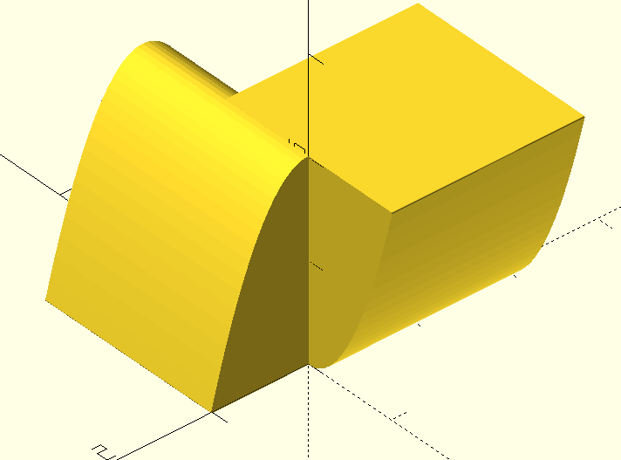
step = 0.05;
//intersection(){
hull(){
rotate([90,0,0])
for(x = [-1:step:1]){
translate([x, 2*x*x, 0])
//cube(size = 0.1, center = true);
//cylinder(1,0.1);
cylinder(h=2,r=0.01, $fn=20, center = false);
}
}
hull(){
rotate([90,0,90])
for(x = [-1:step:1]){
translate([x, -2*x*x+2, 0])
//cube(size = 0.1, center = true);
//cylinder(1,0.1);
cylinder(h=2,r=0.01, $fn=20, center = false);
}
}
//}
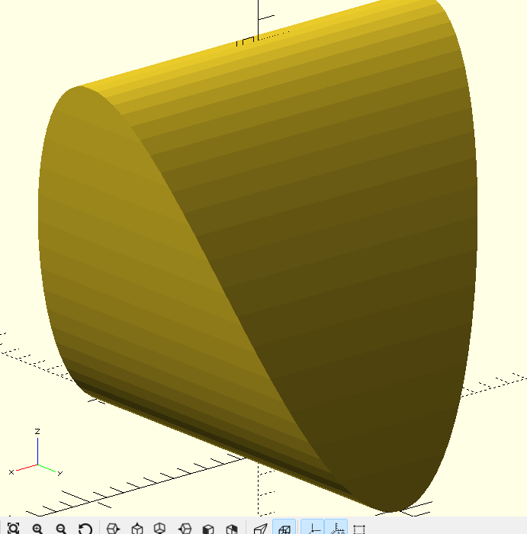
step = 0.05;
intersection(){
hull(){ //figur parallel zury-Achse
translate([0,1,0]){
rotate([90,0,0])
for(x = [-1.1:step:1.1]){
translate([x, 2*x*x, 0])
//cube(size = 0.1, center = true);
//cylinder(1,0.1);
cylinder(h=2,r=0.001, $fn=40, center = false);
}
}
}
hull(){ //figur parallel zur x-Achse
translate([-1,0,0]){
rotate([90,0,90])
for(x = [-1.1:step:1.1]){
translate([x, -2*x*x+2, 0])
//cube(size = 0.1, center = true);
//cylinder(1,0.1);
cylinder(h=2,r=0.001, $fn=40, center = false);
}
}
}
}
21.11.2024
2Lapp_Rotation_20fps_200steps.scad
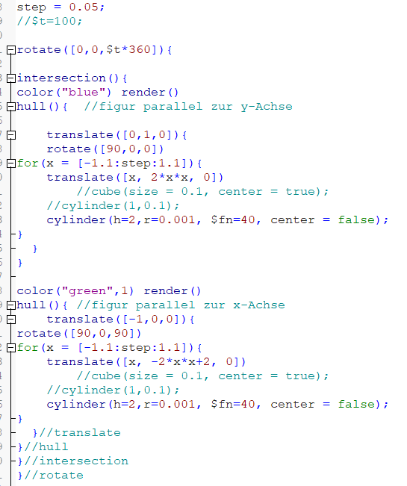
______________________________________________
step = 0.05;
rotate([0,0,$t*360]){
intersection(){
color("blue") render()
hull(){ //figur parallel zur y-Achse

translate([0,1,0]){
rotate([90,0,0])
for(x = [-1.1:step:1.1]){
translate([x, 2*x*x, 0])
//cube(size = 0.1, center = true);
//cylinder(1,0.1);
cylinder(h=2,r=0.001, $fn=40, center = false);
}
}
}
color("green",1) render()
hull(){ //figur parallel zur x-Achse
translate([-1,0,0]){
rotate([90,0,90])
for(x = [-1.1:step:1.1]){
translate([x, -2*x*x+2, 0])
//cube(size = 0.1, center = true);
//cylinder(1,0.1);
cylinder(h=2,r=0.001, $fn=40, center = false);
}
}//translate
}//hull
}//intersection
}//rotate
____________________________________________________
Animation
https://www.instructables.com/Animating-with-OpenSCAD/
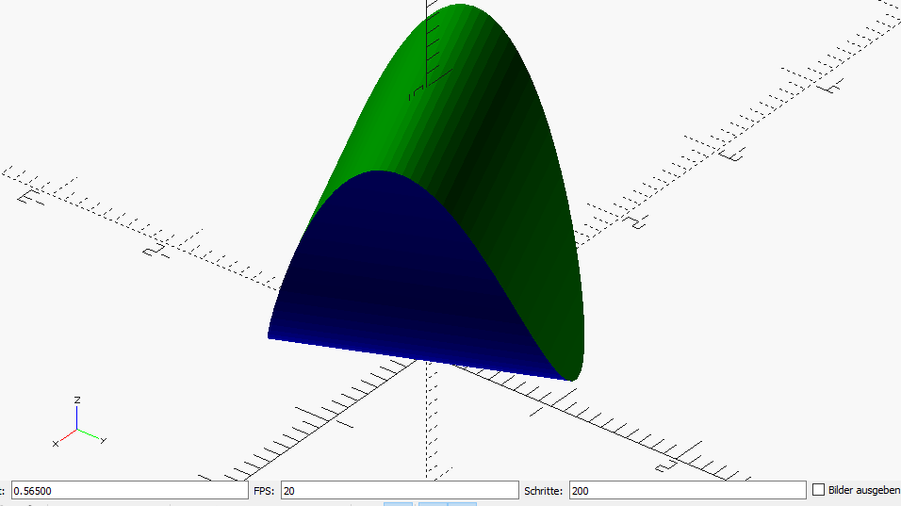
Umwandlung der Frames in gif bzw. mp4!
https://ezgif.com
https://ezgif.com/gif-to-mp4/

